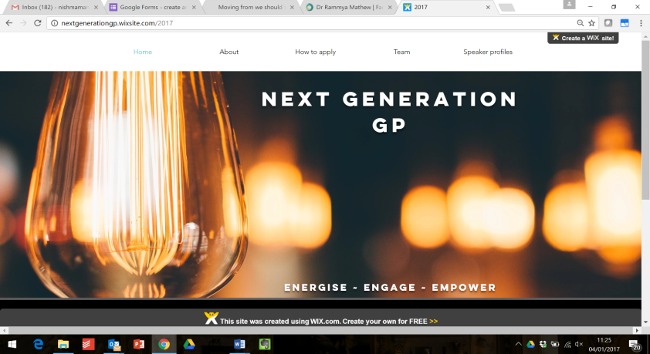

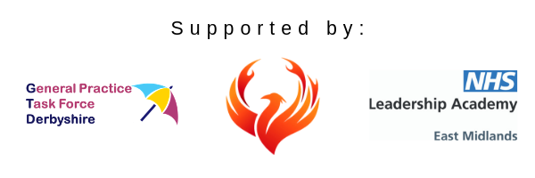

**@NextGGP**

**nextgenerationgp@gmail.com**

**Bit.ly/NextGGP**

Nottinghamshire/Derbyshire

|  |  |  |
| --- | --- | --- |
| **Date** | **Workshop/Lecture** | **Interview** |
| **13 August**  **2019** | **Dr Robert Varnam**  National Director of Professional leadership for Improvement  NHS Englandand NHS Improvement | **Prof Nick Harding OBE**  Founder of the Modality partnership, Senior Clinical Advisor to the Integrated Care System programme |
| **12 September 2019** | **Mr David Ainsworth**  Locality Director Mid Notts CCG | **Dr Duncan Gooch**  GP, Executive Partner and Chair  Derbyshire GP Alliance |
| **3 October 2019** | **Strengths Finder Coaching Session**  **Hannah Miller**  Gallup Accredited Strengths Coach | |
| **21November 2019** | **Dr Claire Marie Thomas**  GP, Past president Vasco Da Gama Movement, Director Empathy LLP | **Dr Carolyn Wilkins OBE**  Chief Executive Oldham Council and Accountable officer NHS Oldham CCG |
| **30January 2020** | **Dr Nikita Kanani MBE**    GP, Acting Primary Care Medical Director  NHS Englandand NHS Improvement | **Prof Simon Gregory DL**  GP, Deputy Medical Director, Primary and Integrated Care, Health Education England |

